Research Findings in GitHub + Local Data Processing
Compliance & Risk one-pager

What we're asking
Two items:
- Confirmation that we may store synthesized research findings in our existing GitHub repository.
- Alignment on the workflow we use to process PII-stripped data locally with Claude Code (raw data stays on the researcher's laptop, never enters the repo).
Skills are already covered by our existing code-storage policy and are not part of this ask.

Why store findings in GitHub
Three concrete reasons, all specific to where research synthesis is heading:
1. Findings are increasingly interactive, and need to render
Claude produces findings as interactive artifacts in addition to written memos — React explorers that let stakeholders drill into themes, embedded dashboards that show survey patterns, hypothesis trees that visualize how research informed design choices. These are code that needs to run to be useful. GitHub Pages hosts them natively as URLs: share a link, stakeholder opens an interactive experience. Stored anywhere else, they become opaque files that have to be downloaded and run locally — which defeats the value of producing them in the first place.
2. Cross-PDLC referencing becomes native
When findings live in the same versioned system as our other research artifacts, they become first-class citizens in how product work happens. A discussion guide can reference findings from a previous study. A skill that analyzes new transcripts can pull patterns from prior work. PRDs and design docs can link to the exact finding that motivated a feature. The connections we want to make across discovery, design, build, and measure become technical realities rather than procedural aspirations.
3. Decision-to-research traceability we haven't had before
Every finding has a commit history (who wrote it, when, what changed) plus provenance metadata (source tool, study ID, PII-strip identifier, skill version). This creates traceability our current research systems can't match:
- "What research justified this decision?" — point to a specific commit.
- "What did we know at the time we made this call?" — check out the repo at that date.
- "How has our understanding of X evolved?" — read the finding's commit history.
- "Has anyone updated this finding since?" — git log answers in seconds.
This kind of decision auditability is especially valuable as more decisions get informed by AI-assisted research synthesis.

How we process raw research data
We want compliance and risk aligned on this workflow. The key property: raw data — transcripts and survey responses — never enters the repo. It stays on the researcher's laptop during analysis and is deleted afterward.
The workflow:
- Researcher downloads data from approved source tools (Qualtrics, UserTesting, dscout, etc.) into a local working folder.
- PII is stripped via the already-approved process. Output stays in the same local folder.
- Claude Code runs locally, reading skills from the GitHub repo and stripped data from the local folder.
- Claude writes synthesized findings to the repo with provenance metadata: source tool, study ID, export date, PII-strip identifier, skill version.
- The local working folder is deleted. Nothing about the raw data persists outside the source tool.
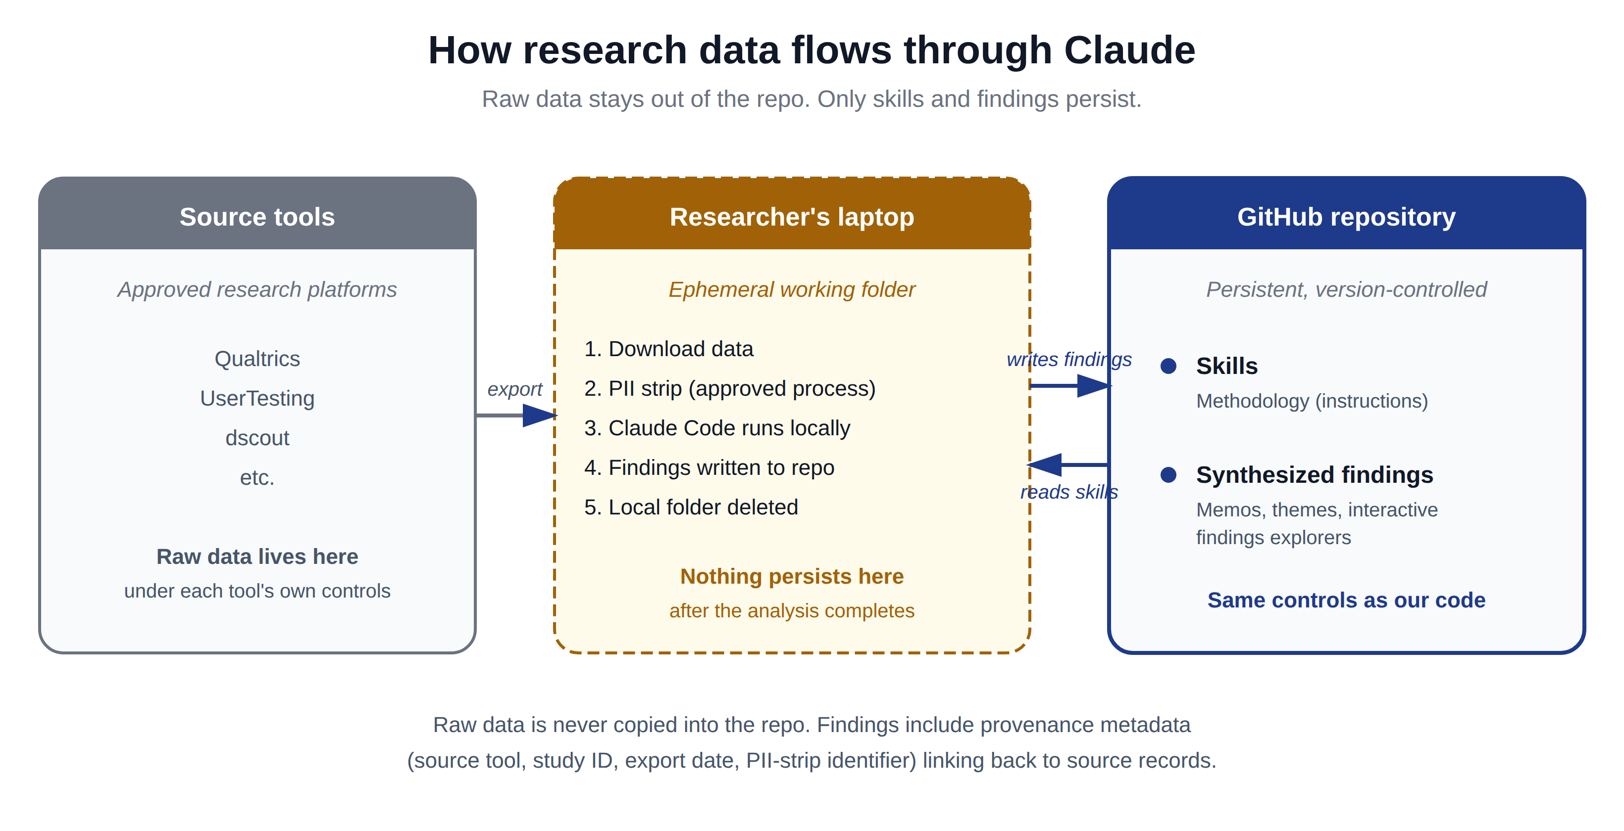

What is already approved (context, not asking)
- GitHub as a storage location — covered by existing code-storage policy.
- Skills — instructions written like code; fall under the same code-storage policy.
- The PII-stripping process — already defined and approved.

What never enters the repo
- Raw research data — processed ephemerally on the researcher's laptop and deleted after analysis.
- Video recordings of research sessions.
- Audio recordings of any kind.
- Anything containing PII — no raw or unstripped data ever enters the repo.

Why this fits within existing controls
- Findings are stored with the same access controls and audit history already approved for our code.
- Raw data never persists in a new location; it lives only in approved source tools.
- Findings include provenance metadata linking each deliverable to its source records, so lineage is traceable even though intermediate files are gone.
- Excluding video and audio removes the highest-risk artifact types from our data surface entirely.

Scope at a glance
